**Spring REST using Spring Boot 3**

**EXERCISE 4: REST-Country Web Service**

**Source Code**

**OBJECTIVE:**

Create a REST endpoint:

URL: http://localhost:8083/country

Returns a JSON response of **India's country details**

Controller: CountryController

Method: getCountryIndia()

Load India as a Spring bean from an XML configuration.

**STEP 1: Create the Country Model Class**

**Country.java**

**package com.cognizant.springlearn.model;**

public class Country {

private String code;

private String name;

// Getters and Setters

public String getCode() {

return code;

}

public void setCode(String code) {

this.code = code;

}

public String getName() {

return name;

}

public void setName(String name) {

this.name = name;

}

}

**STEP 2: Create Spring XML Configuration**

**country.xml in src/main/resources**

<?xml version="1.0" encoding="UTF-8"?>

<beans xmlns="http://www.springframework.org/schema/beans"

xmlns:xsi="http://www.w3.org/2001/XMLSchema-instance"

xsi:schemaLocation="

http://www.springframework.org/schema/beans

http://www.springframework.org/schema/beans/spring-beans.xsd">

<bean id="in" class="com.cognizant.springlearn.model.Country">

<property name="code" value="IN"/>

<property name="name" value="India"/>

</bean>

</beans>

**STEP 3: Create the Controller**

**CountryController.java**

**java**

package com.cognizant.springlearn.controller;

import com.cognizant.springlearn.model.Country;

import org.slf4j.Logger;

import org.slf4j.LoggerFactory;

import org.springframework.context.ApplicationContext;

import org.springframework.context.support.ClassPathXmlApplicationContext;

import org.springframework.web.bind.annotation.RequestMapping;

import org.springframework.web.bind.annotation.RestController;

@RestController

public class CountryController {

private static final Logger LOGGER = LoggerFactory.getLogger(CountryController.class);

@RequestMapping("/country")

public Country getCountryIndia() {

LOGGER.info("START - getCountryIndia()");

ApplicationContext context = new ClassPathXmlApplicationContext("country.xml");

Country country = (Country) context.getBean("in");

LOGGER.info("END - getCountryIndia()");

return country;

}

}

**STEP 4: application.properties**

**Ensure this exists:**

**Properties:**

server.port=8083

**STEP 5: Run the Application In Eclipse:**

Run your main class (typically SpringLearnApplication.java)

**STEP 6: Test the Endpoint**

**In Browser**

http://localhost:8083/country

**Console Output:**

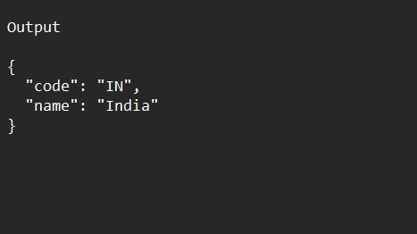

**STEP 7: Understanding the Execution & Internals**

* ApplicationContext loads country.xml
* Bean with ID "in" is fetched and cast to Country
* That Country object is returned
* Spring Boot automatically serializes the object to JSON